# Command 1: Query: list the supplier number and supplier name for those suppliers who ship every part.

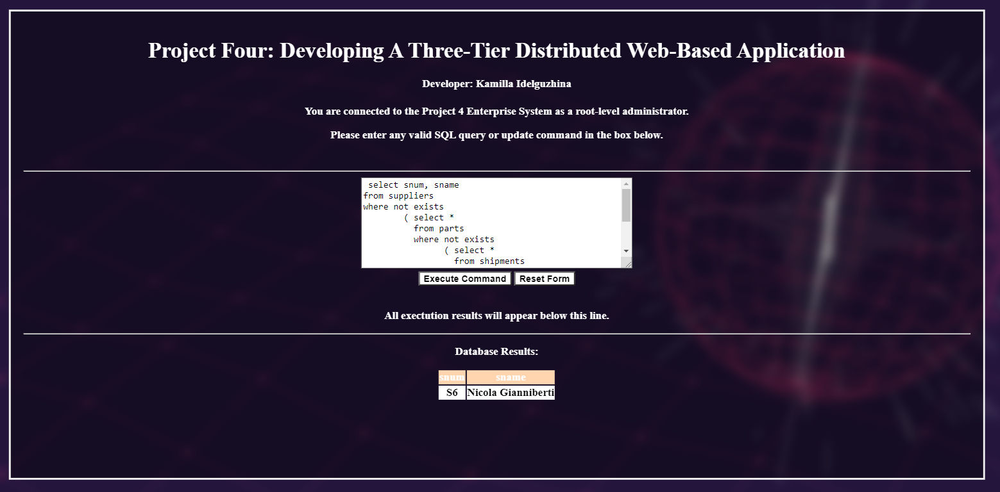

# Command 2 is a multi-part sequence that will trigger the business logic.

# The first part is a query to illustrate all supplier information before the update.

# The second part performs the update and causes the business logic to trigger.

# The third part is a query that illustrates all supplier information after the update/

# In the non-bonus version of the program, supplier numbers S1, S12, S17, S21, S22, S3, S44, S5, and S6 all

# have their status value updated. In the bonus version of the program, only supplier number S5 will

# receive a status update.

# Command 2A: Query: list all supplier information.

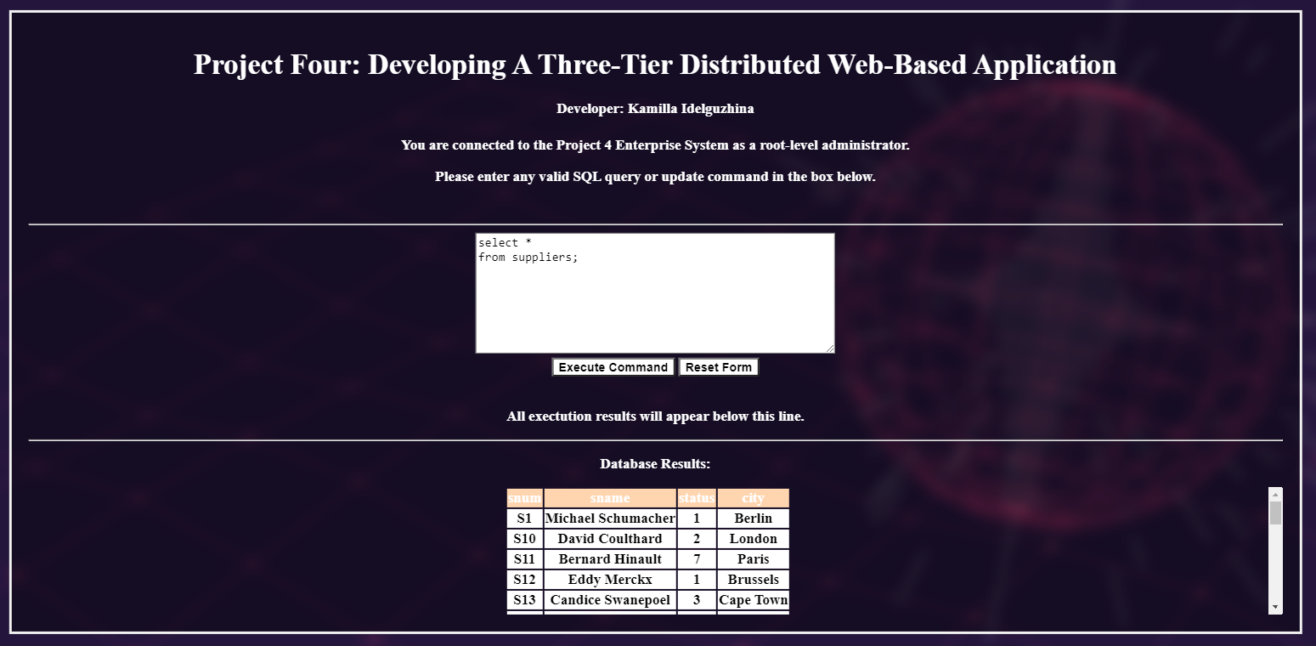

# Command 2B: add a new record to shipments table (S5, P6, J7, 400)

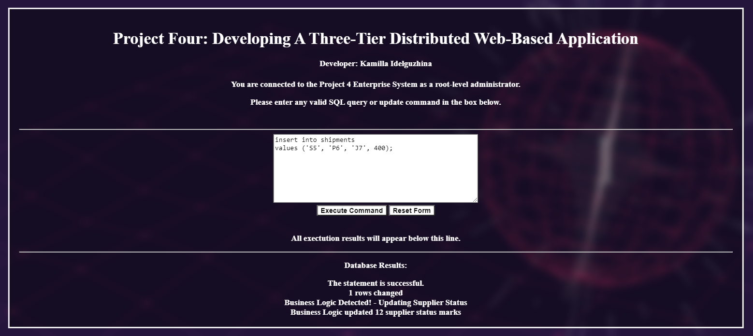

# Command 2C: list all supplier information.

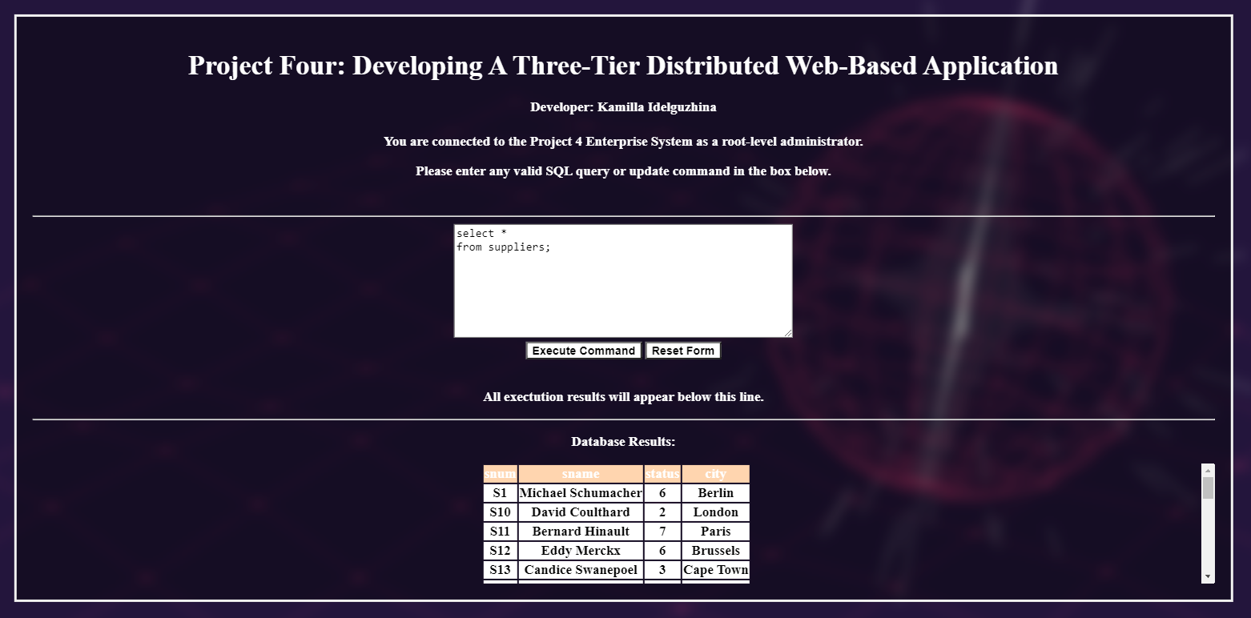

# Command 3 is a multi-part that does not cause the business logic to trigger

# Command 3A list all supplier information

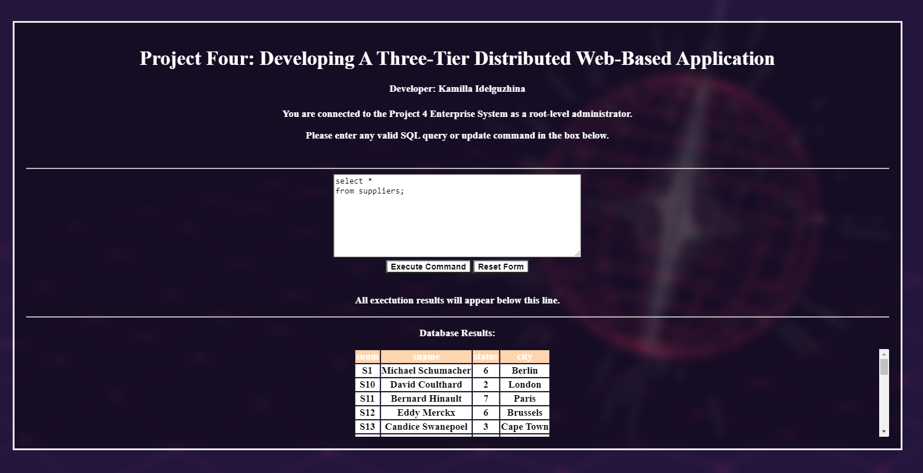

# Command 3B: add a new record to the supplier table (S39, Candice Swanepoel, 10, Cardiff)

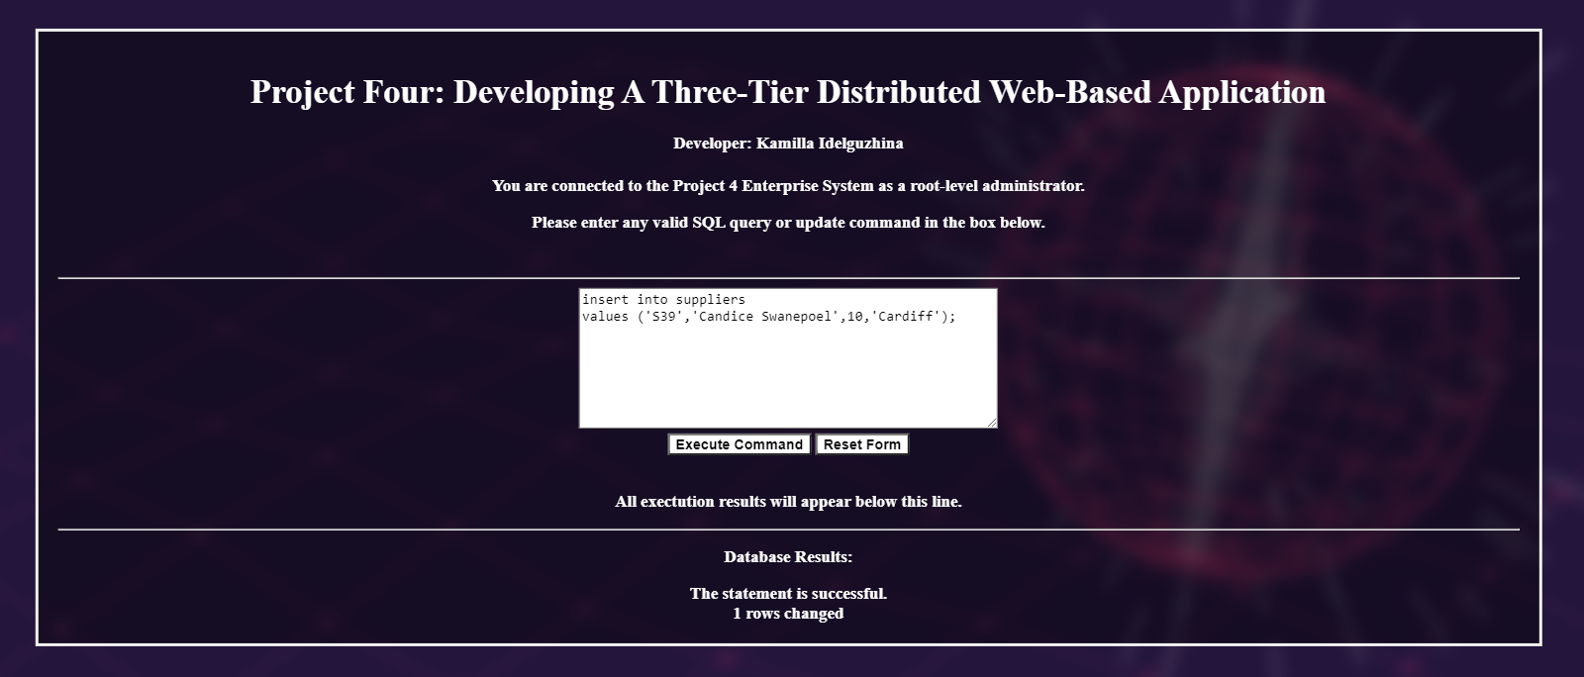

# Command 3C: list all supplier information.

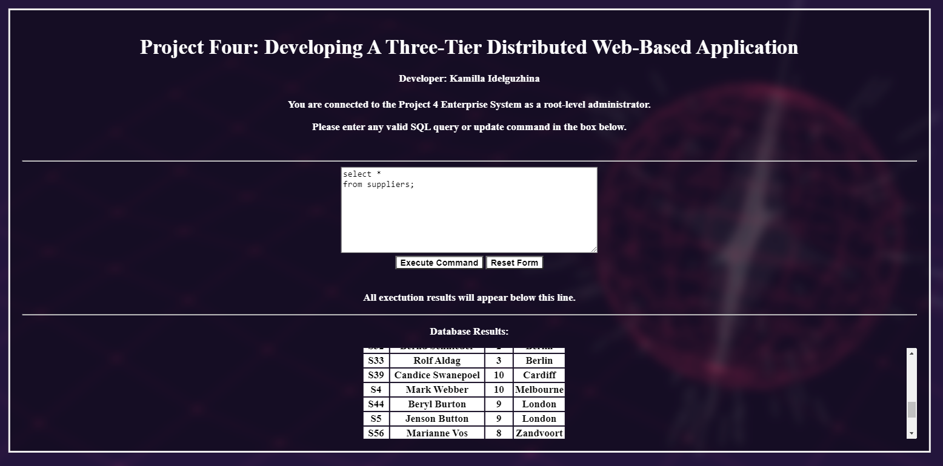

# Command 3D: add a new record to shipments table (S39, P3, J1, 20), business logic will trigger but no status marks updated

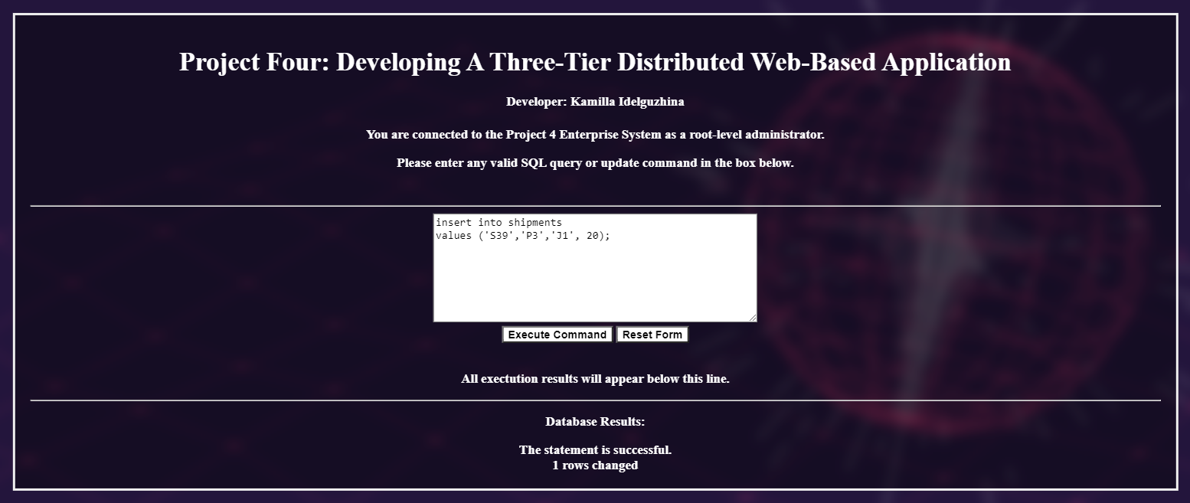

# Command 3E: list all supplier information

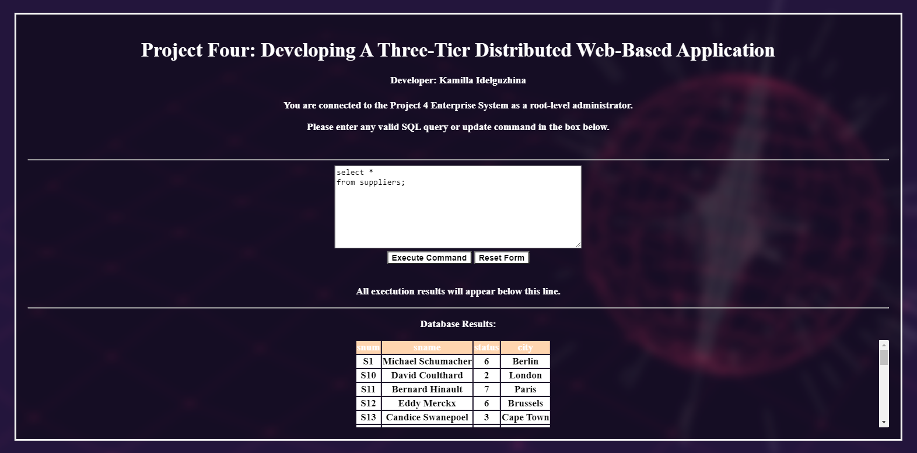

# Command 4: List the snum, sname, and pnum for those suppliers who ship the

# same part to every job. This is a fairly complex SQL nested query.

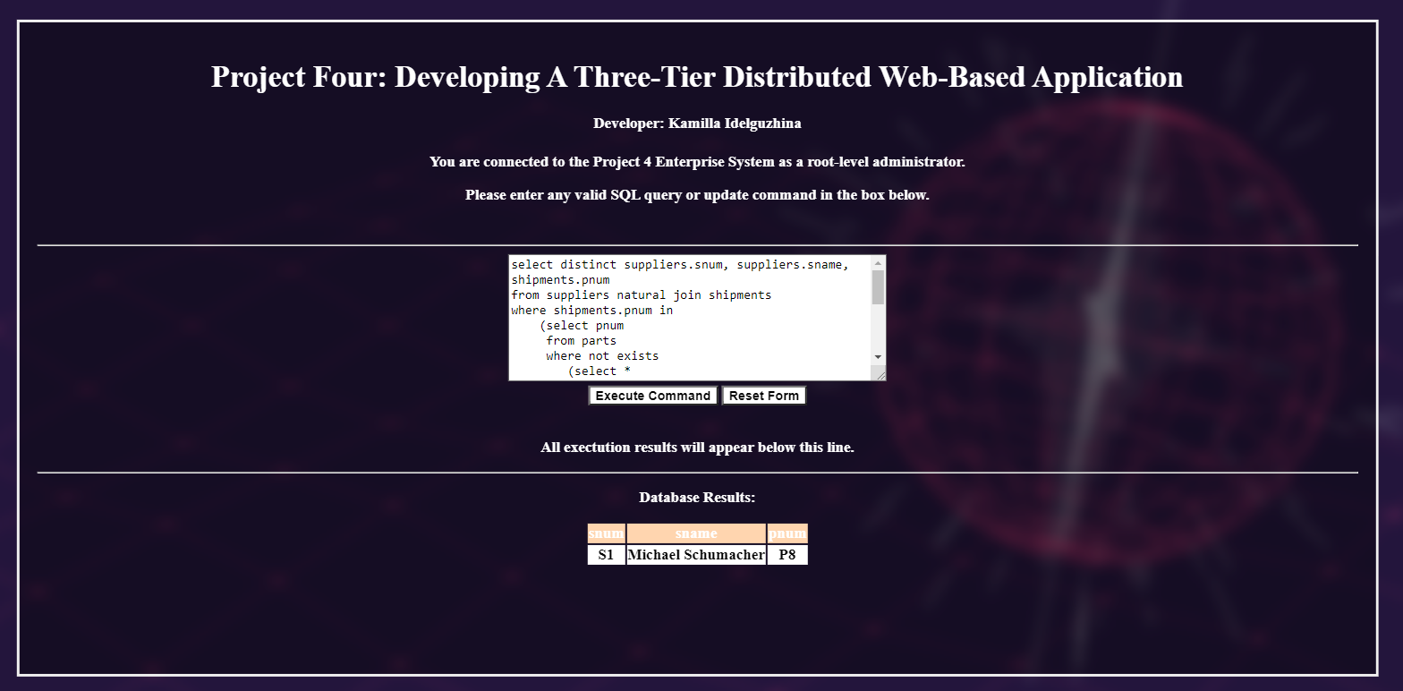

# Command 5 is a multipart transaction that will cause the business logic to trigger

#

# The first part is a query to illustrate all shipment information before the update.

# The second part performs the update and causes the business logic to trigger.

# The third part is a query that illustrates all shipment information after the update/

# In the non-bonus version of the program, supplier numbers S1, S2, S12, S17, S3, and S6 all

# have their status value updated.

# In the bonus verison of the program, only supplier numbers S1, S2, and S3 will have their status

# value updated.

# Command 5A: List all supplier information

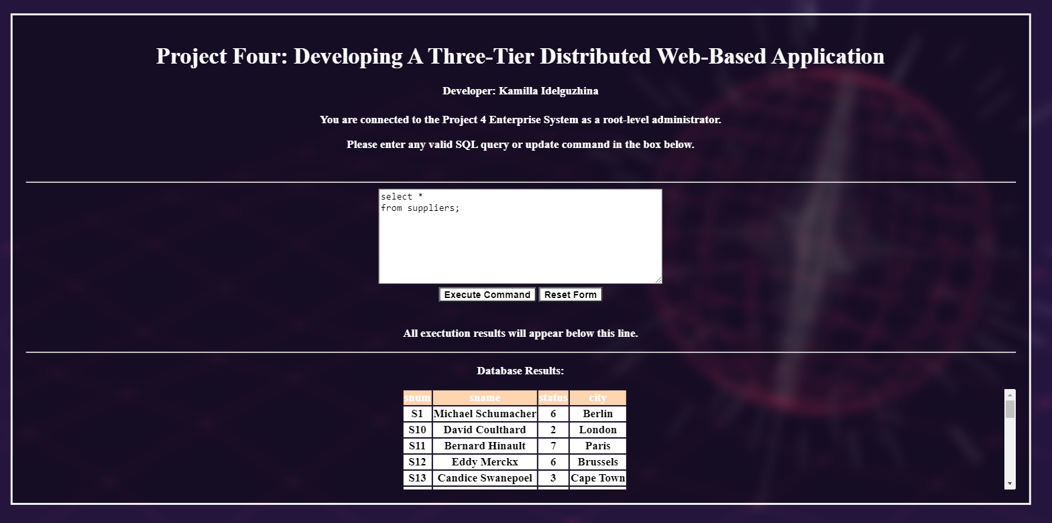

# Command 5B: List all shipment information

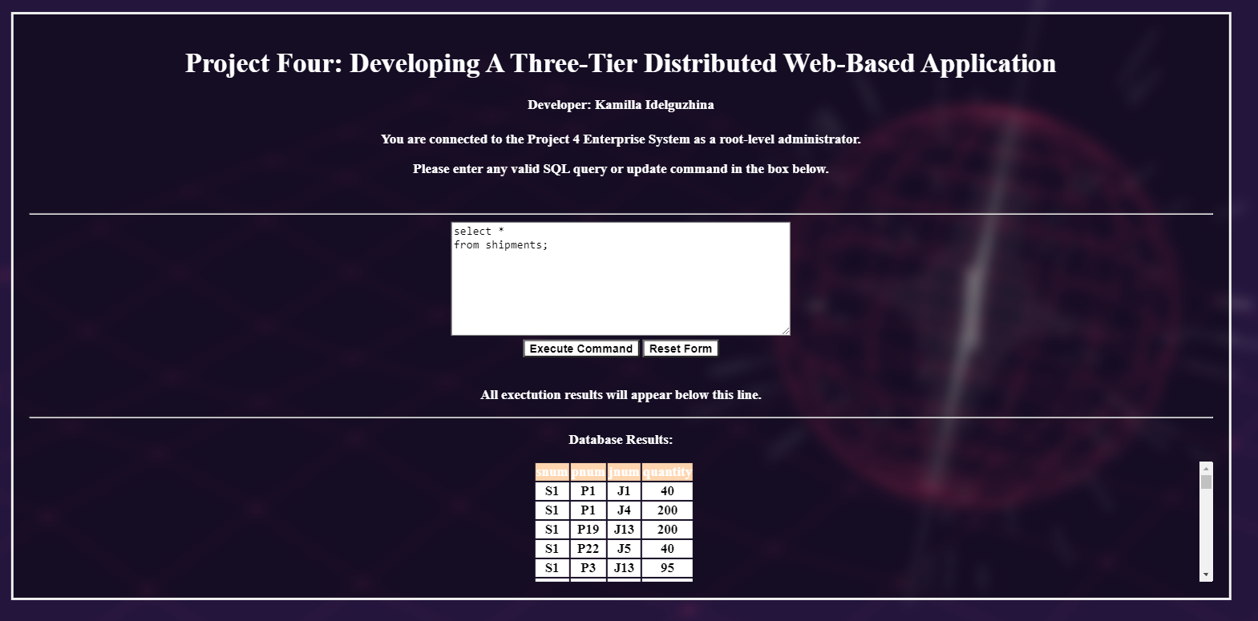

# Command 5C: Update the shipments table by increasing the quantity by 10 every shipment of part P3.

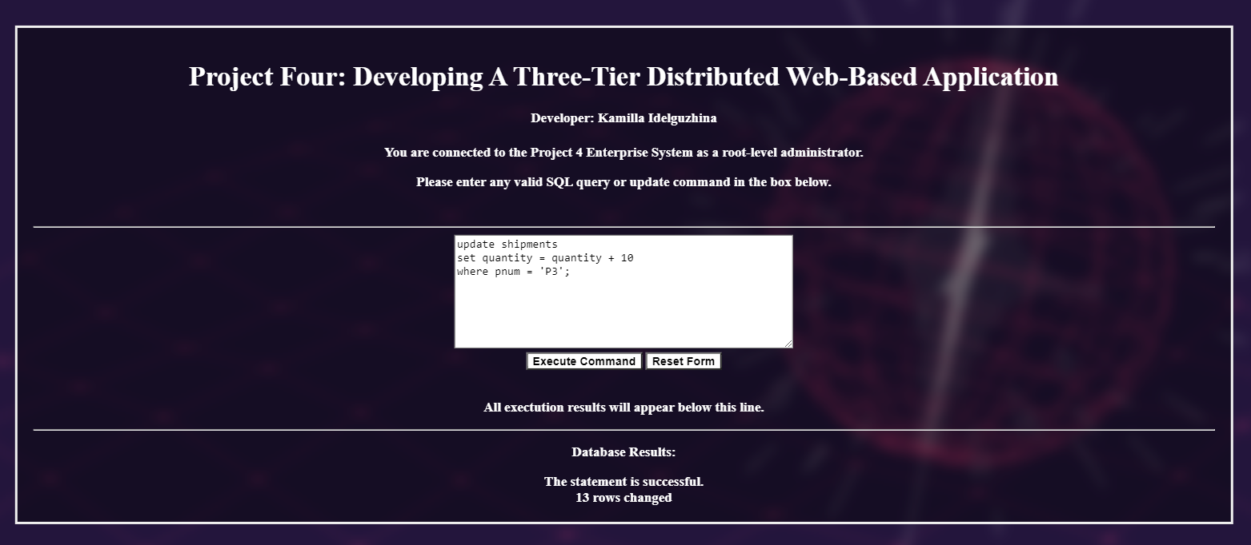

# Command 5D: List all shipment information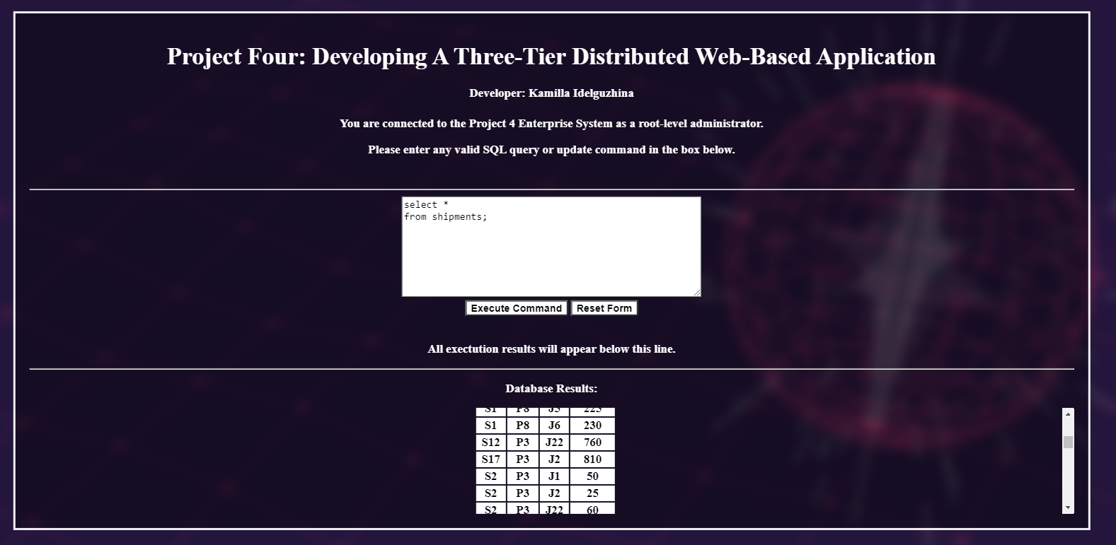

# Command 5E: List all supplier information

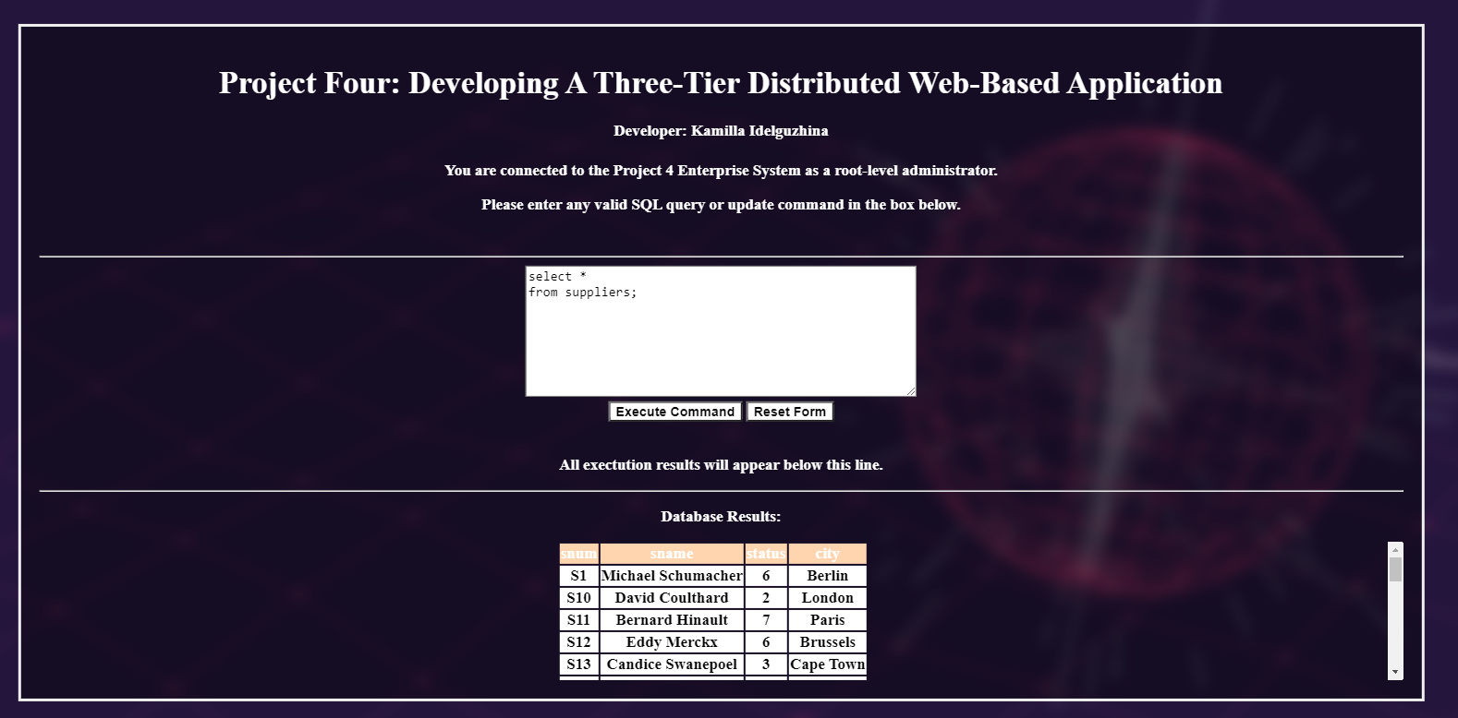

# Command 6: List the snum, and sname for those suppliers who ship only green parts.

# Output should list only supplier number S44

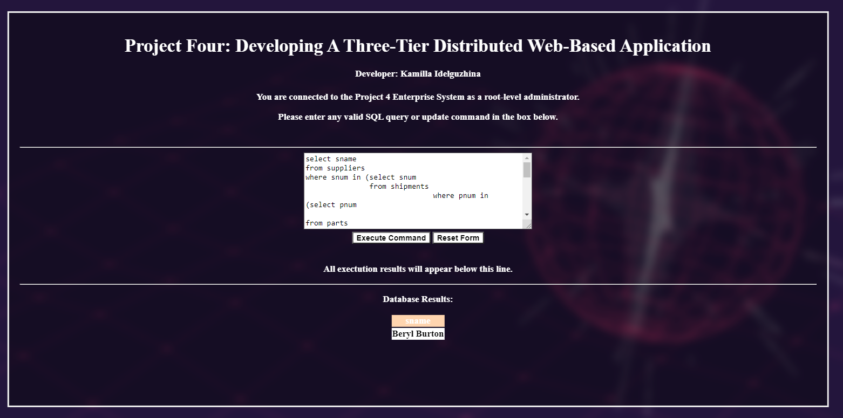

# Command 7: This will generate an intentional error in command syntax.

# Output should show the error message generated by catching an SQLEception

# Output would be similar to the one shown on page 8 of the project document.

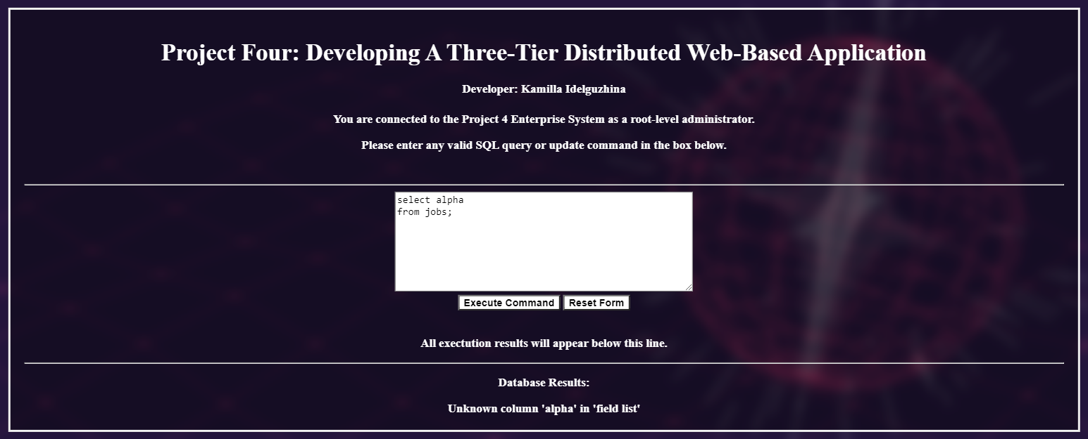

############################################################

# Command 8: This will not trigger the business logic.

# Output should show the message indicating that the command was executed but the business logic has not triggered

# The output message would be like the one on page 12 of the project document.

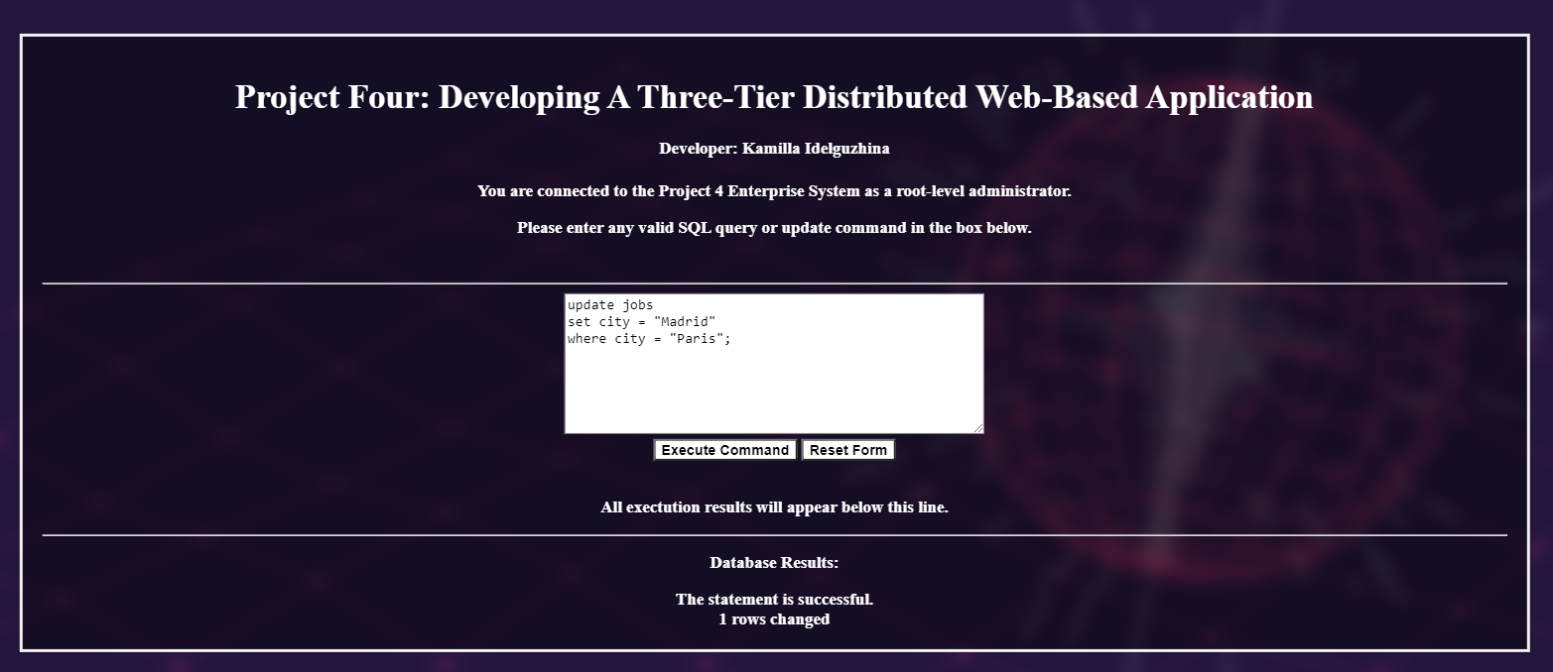

# Command 9: Verify that command #8 did in fact update the jobs table

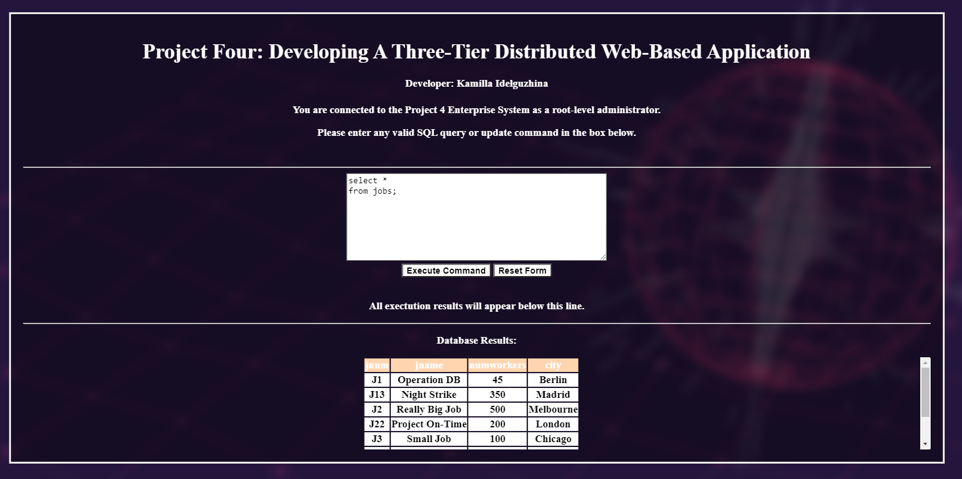

# Command 10: This is a basic select command using an aggregation operator

# Business logic not triggered and no table is updated.